Hands-on Crossplane with Argo CD: Multi-cloud Kubernetes Deployment

Report by: DucTruong Huynh

**Abstract**:   
Focuses on a practical assignment report detailing the utilization of Crossplane and Argo CD for multi-cloud Kubernetes deployment. Cover the integration of these tools to provision infrastructure across Azure, AWS, GCP, and YC while adhering to GitOps principles for continuous delivery.

Table of content:

1. Before start 1

2. Building Kubernetes Cluster on Azure: 2

2.1 Prerequisite 2

2.2 Configuration: 2

2.3 Result 4

2. Building Kubernetes Cluster on AWS: 5

2.1 Prerequisite 5

2.2 Configuration: 6

2.3 Result 7

3. Building Kubernetes Cluster on GCP: 8

3.1 Prerequisite 8

3.2 Configuration: 9

3.3 Result: 10

4. Building Kubernetes Cluster on YC: 11

4.1 Prerequisite 11

4.2 Configuration: 12

4.3 Result: 14

# 1. Before start

**- Kubernetes Cluster**: Ensure you have a Kubernetes cluster deployed on your preferred cloud provider (Azure, AWS, GCP) or on-premises.

- CLI: Kubectl, helm

**- Argo CD Installation**:

kubectl create namespace argocd  
kubectl apply -n argocd -f <https://raw.githubusercontent.com/argoproj/argo-cd/stable/manifests/install.yaml>

Install Crossplane in ArgoCD:

apiVersion: argoproj.io/v1alpha1

kind: Application

metadata:

name: crossplane

namespace: argocd

finalizers: []

spec:

destination:

name: ''

namespace: crossplane-system

server: '<https://kubernetes.default.svc>'

source:

path: ''

repoURL: '<https://charts.crossplane.io/stable>'

targetRevision: 1.15.2

chart: crossplane

sources: []

project: default

syncPolicy:

automated:

prune: true

selfHeal: true

syncOptions:

- CreateNamespace=true

Then manage it such as another ArgoCD app

# 2. Building Kubernetes Cluster on Azure:

## 2.1 Prerequisite

To authenticate with crossplane, you need to provide a secret which will allow you authenticate to Azure. To do that, you can authen via AzCli:

az ad sp create-for-rbac

--sdk-auth

--role Owner

--scopes <subscriptionId>

Then store it as a json file, for example azure-credentials.json

Then, create secrets with kubectl, this one will be used to mapping to ProviderRef later:  
for example:  
kubectl create secret generic azure-secret -n crossplane-system --from-file=creds=azure-credentials.json

Then, later you can create Provider config:

:  
apiVersion: azure.upbound.io/v1beta1

kind: ProviderConfig

metadata:

name: azure-provider

annotations:

argocd.argoproj.io/sync-wave: "2"

argocd.argoproj.io/sync-options: "SkipDryRunOnMissingResource=true"

spec:

credentials:

source: Secret

secretRef:

namespace: crossplane-system

name: azure-secrets

key: creds

## 2.2 Configuration:

Provider:

apiVersion: pkg.crossplane.io/v1

kind: Provider

metadata:

name: provider-azure-network

annotations:

argocd.argoproj.io/sync-wave: "0"

argocd.argoproj.io/sync-options: "SkipDryRunOnMissingResource=true"

spec:

package: xpkg.upbound.io/upbound/provider-azure-network:v0.42.1

And

apiVersion: pkg.crossplane.io/v1

kind: Provider

metadata:

name: provider-azure-containerservice

annotations:

argocd.argoproj.io/sync-wave: "6"

argocd.argoproj.io/sync-options: "SkipDryRunOnMissingResource=true"

spec:

package: xpkg.upbound.io/upbound/provider-azure-containerservice:v1.0.1

Reference, read further:

<https://marketplace.upbound.io/providers/upbound/provider-azure-network/v1.1.0>

<https://marketplace.upbound.io/providers/upbound/provider-azure-containerservice/v1.1.0>

Application:

Reference to github: <https://github.com/huynhduc0/argo-demo/tree/master/aks/crossplane>

With application:

apiVersion: argoproj.io/v1alpha1

kind: Application

metadata:

name: aks

namespace: argocd

spec:

destination:

name: ''

namespace: dev

server: '<https://kubernetes.default.svc>'

source:

path: aks/crossplane

repoURL: '<https://github.com/huynhduc0>'

targetRevision: HEAD

sources: []

project: default

syncPolicy:

automated:

prune: true

selfHeal: true

syncOptions:

- CreateNamespace=true

## 2.3 Result

After run, we can see our AKS infrastructure as application struct below:

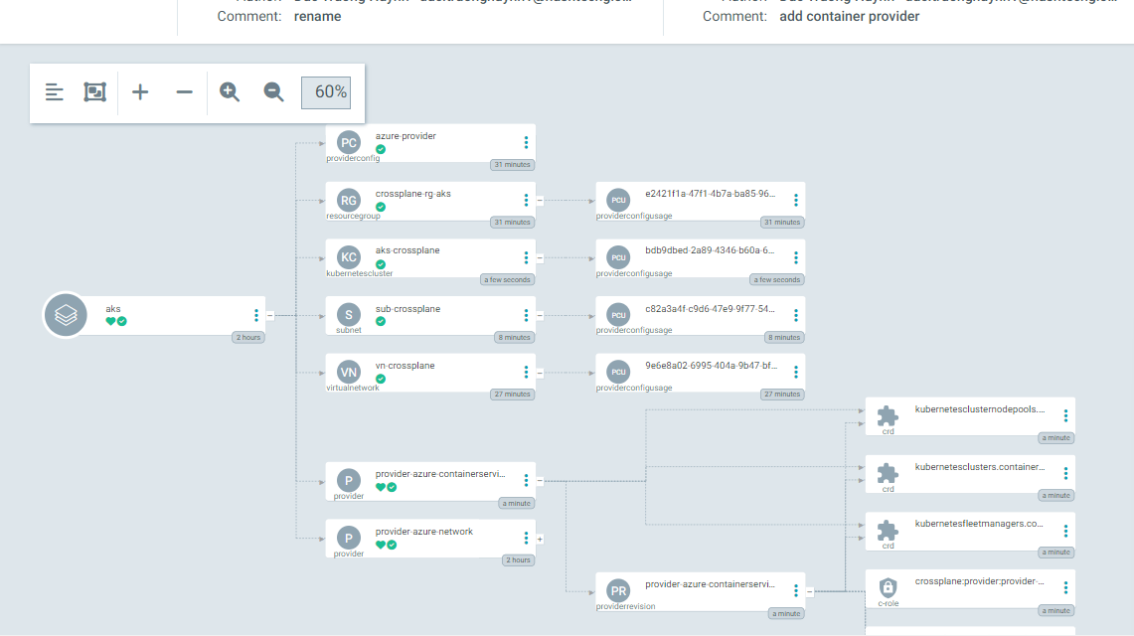And Resource created on Azure:  
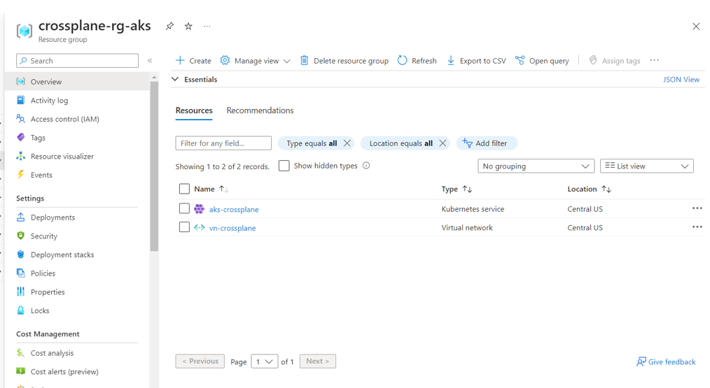

# 2. Building Kubernetes Cluster on AWS:

## 2.1 Prerequisite

Same to Azure, we also need create a secrets, however, json format will not be use.  
Login to your AWS account and get AWS_ACCESS_KEY_ID and AWS_SECRET_ACCESS_KEY, grant nessesary permission such as EKS, VPC...

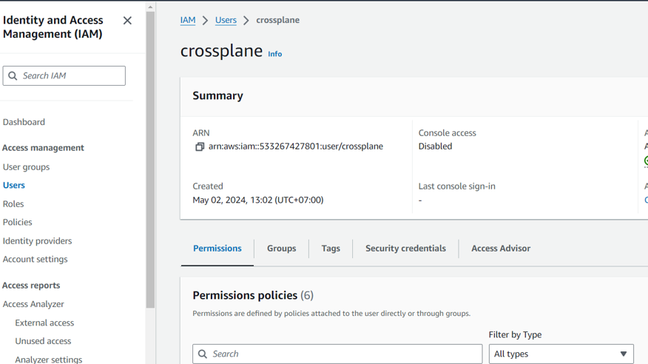

then create a file, such as aws-credentials.txt:  
AWS_ACCESS_KEY_ID=<your key>

AWS_SECRET_ACCESS_KEY= <your key>  
then, create with kubectl:

kubectl create secret generic aws-secret -n crossplane-system --from-file=creds=aws-credentials.txt

And your provider can be:  
apiVersion: aws.upbound.io/v1beta1

kind: ProviderConfig

metadata:

name: aws-provider

annotations:

argocd.argoproj.io/sync-wave: "1"

argocd.argoproj.io/sync-options: "SkipDryRunOnMissingResource=true"

spec:

credentials:

source: Secret

secretRef:

namespace: crossplane-system

name: aws-creds

key: creds

## 2.2 Configuration:

Provider needed, use also use another once for each service, or for all:

apiVersion: pkg.crossplane.io/v1

kind: Configuration

metadata:

name: configuration-aws-eks

annotations:

argocd.argoproj.io/sync-wave: "0"

argocd.argoproj.io/sync-options: "SkipDryRunOnMissingResource=true"

spec:

package: xpkg.upbound.io/upbound/configuration-aws-eks:v0.7.0

Reference to github: <https://github.com/huynhduc0/argo-demo/tree/master/eks/crossplane>

With application:

apiVersion: argoproj.io/v1alpha1

kind: Application

metadata:

name: eks

namespace: argocd

spec:

destination:

name: ''

namespace: dev

server: '<https://kubernetes.default.svc>'

source:

path: eks/crossplane

repoURL: '<https://github.com/huynhduc0>'

targetRevision: HEAD

sources: []

project: default

syncPolicy:

automated:

prune: true

selfHeal: false

syncOptions:

- CreateNamespace=true

## 2.3 Result

Then you can see infrastructure:  
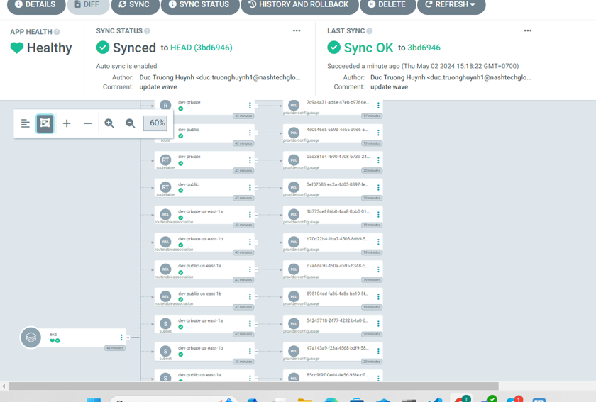

# 3. Building Kubernetes Cluster on GCP:

## 3.1 Prerequisite

Create a Service Accout with GKE permission,

Then create key and download secrets:

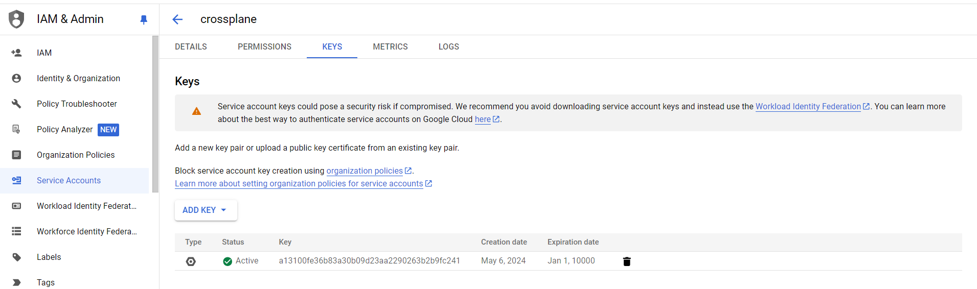Then run:

kubectl create secret generic gcp-secret -n crossplane-system --from-file=creds=<downloaded file.json>

Then, later you can create Provider config:

:  
apiVersion: gcp.upbound.io/v1beta1

kind: ProviderConfig

metadata:

name: {{.Values.provider.name}}

annotations:

argocd.argoproj.io/sync-wave: "1"

argocd.argoproj.io/sync-options: "SkipDryRunOnMissingResource=true"

spec:

projectID: arcane-geode-422508-p4

credentials:

source: Secret

secretRef:

namespace: crossplane-system

name: gcp-secret

key: creds

## 3.2 Configuration:

Provider:

apiVersion: pkg.crossplane.io/v1

kind: Provider

metadata:

annotations:

argocd.argoproj.io/sync-wave: "0"

argocd.argoproj.io/sync-options: "SkipDryRunOnMissingResource=true"

name: provider-gcp-compute

spec:

package: xpkg.upbound.io/upbound/provider-gcp-compute:v1.1.0

---

apiVersion: pkg.crossplane.io/v1

kind: Provider

metadata:

annotations:

argocd.argoproj.io/sync-wave: "0"

argocd.argoproj.io/sync-options: "SkipDryRunOnMissingResource=true"

name: provider-gcp-container

spec:

package: xpkg.upbound.io/upbound/provider-gcp-container:v1.1.0

Reference, read further:

<https://marketplace.upbound.io/providers/upbound/provider-gcp-compute/v1.1.0>

<https://marketplace.upbound.io/providers/upbound/provider-gcp-container/v1.1.0>

Application:

Reference to github:

<https://github.com/huynhduc0/argo-demo/tree/master/gke/crossplane>

With application:

apiVersion: argoproj.io/v1alpha1

kind: Application

metadata:

name: gke

namespace: argocd

spec:

destination:

name: ''

namespace: dev3

server: '<https://kubernetes.default.svc>'

source:

path: gke/crossplane

repoURL: '<https://github.com/huynhduc0/argo-demo/>'

targetRevision: HEAD

helm:

valueFiles:

- values.yaml

sources: []

project: default

syncPolicy:

automated:

prune: true

selfHeal: true

syncOptions:

- CreateNamespace=true

## 3.3 Result:

Then you can see infrastructure:

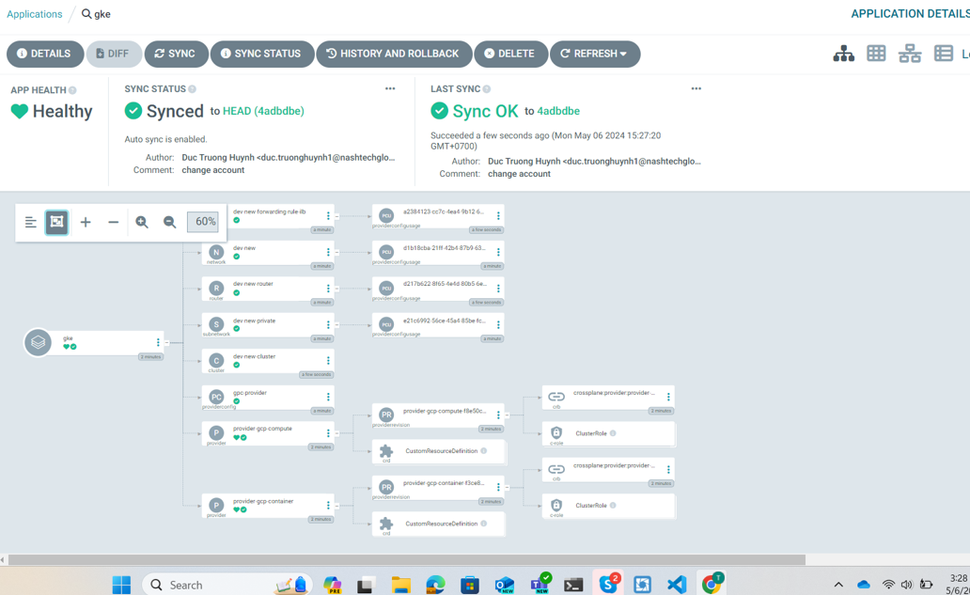

And on Google Cloud Console:

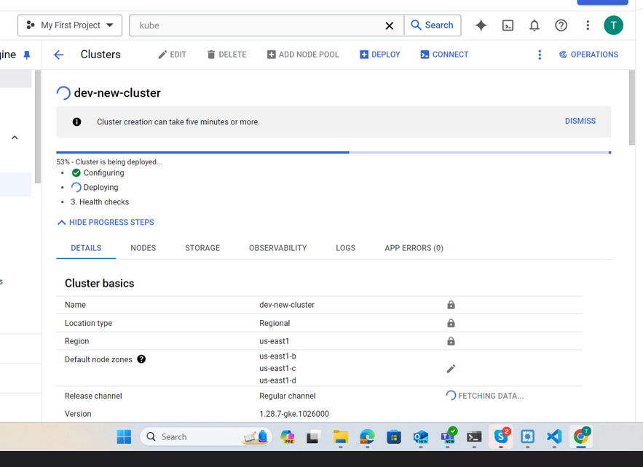

# 4. Building Kubernetes Cluster on YC:

## 4.1 Prerequisite

Create a Service Account with MKS (Manage Kubenertes Service) permission,

Then create key and download secrets:

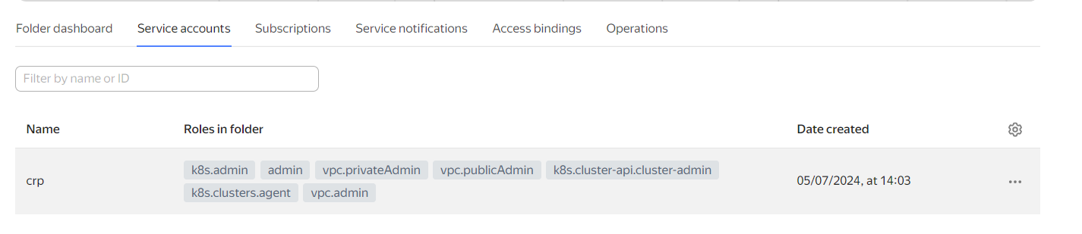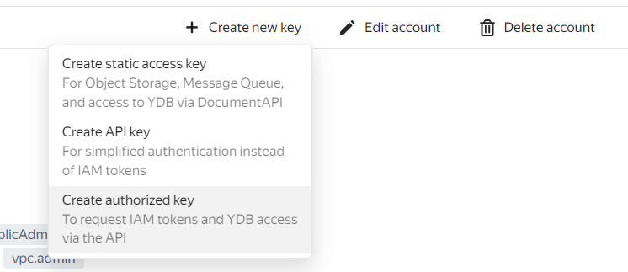

Then run:

kubectl create secret generic yc-secret -n crossplane-system --from-file=creds=<downloaded file.json>

Then, later you can create Provider config:

:  
apiVersion: yandex-cloud.upjet.crossplane.io/v1beta1

kind: ProviderConfig

metadata:

name: yc-provider

annotations:

argocd.argoproj.io/sync-wave: "1"

argocd.argoproj.io/sync-options: "SkipDryRunOnMissingResource=true"

spec:

credentials:

source: Secret

secretRef:

namespace: crossplane-system

name: yc-secret

key: creds

## 4.2 Configuration:

Provider:

apiVersion: pkg.crossplane.io/v1

kind: Provider

metadata:

annotations:

argocd.argoproj.io/sync-wave: "0"

argocd.argoproj.io/sync-options: "SkipDryRunOnMissingResource=true"

name: provider-upjet-yc

spec:

package: xpkg.upbound.io/tages/provider-upjet-yc:v1.1.0

Reference, read further:

<https://marketplace.upbound.io/providers/tages/provider-upjet-yc/v1.1.0>

Application:

Reference to github:

<https://github.com/huynhduc0/argo-demo/tree/master/yck/crossplane>

With application:

apiVersion: argoproj.io/v1alpha1

kind: Application

metadata:

name: gke

namespace: argocd

spec:

destination:

name: ''

namespace: dev3

server: '<https://kubernetes.default.svc>'

source:

path: yck/crossplane

repoURL: '<https://github.com/huynhduc0/argo-demo/>'

targetRevision: HEAD

helm:

valueFiles:

- values.yaml

sources: []

project: default

syncPolicy:

automated:

prune: true

selfHeal: true

syncOptions:

- CreateNamespace=true

## 4.3 Result:

Then you can see infrastructure:

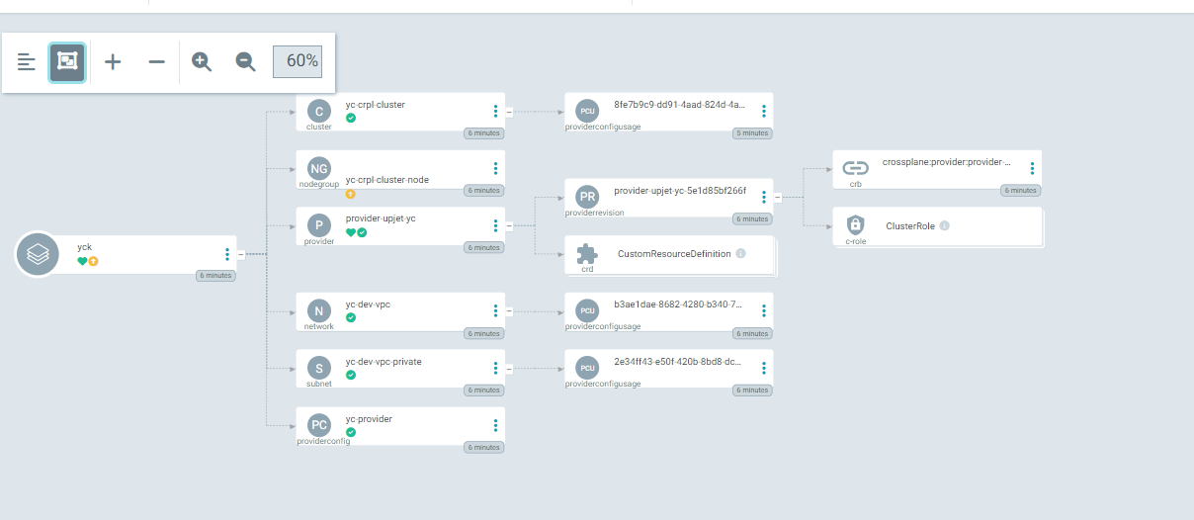

And on Yandex Cloud Console:

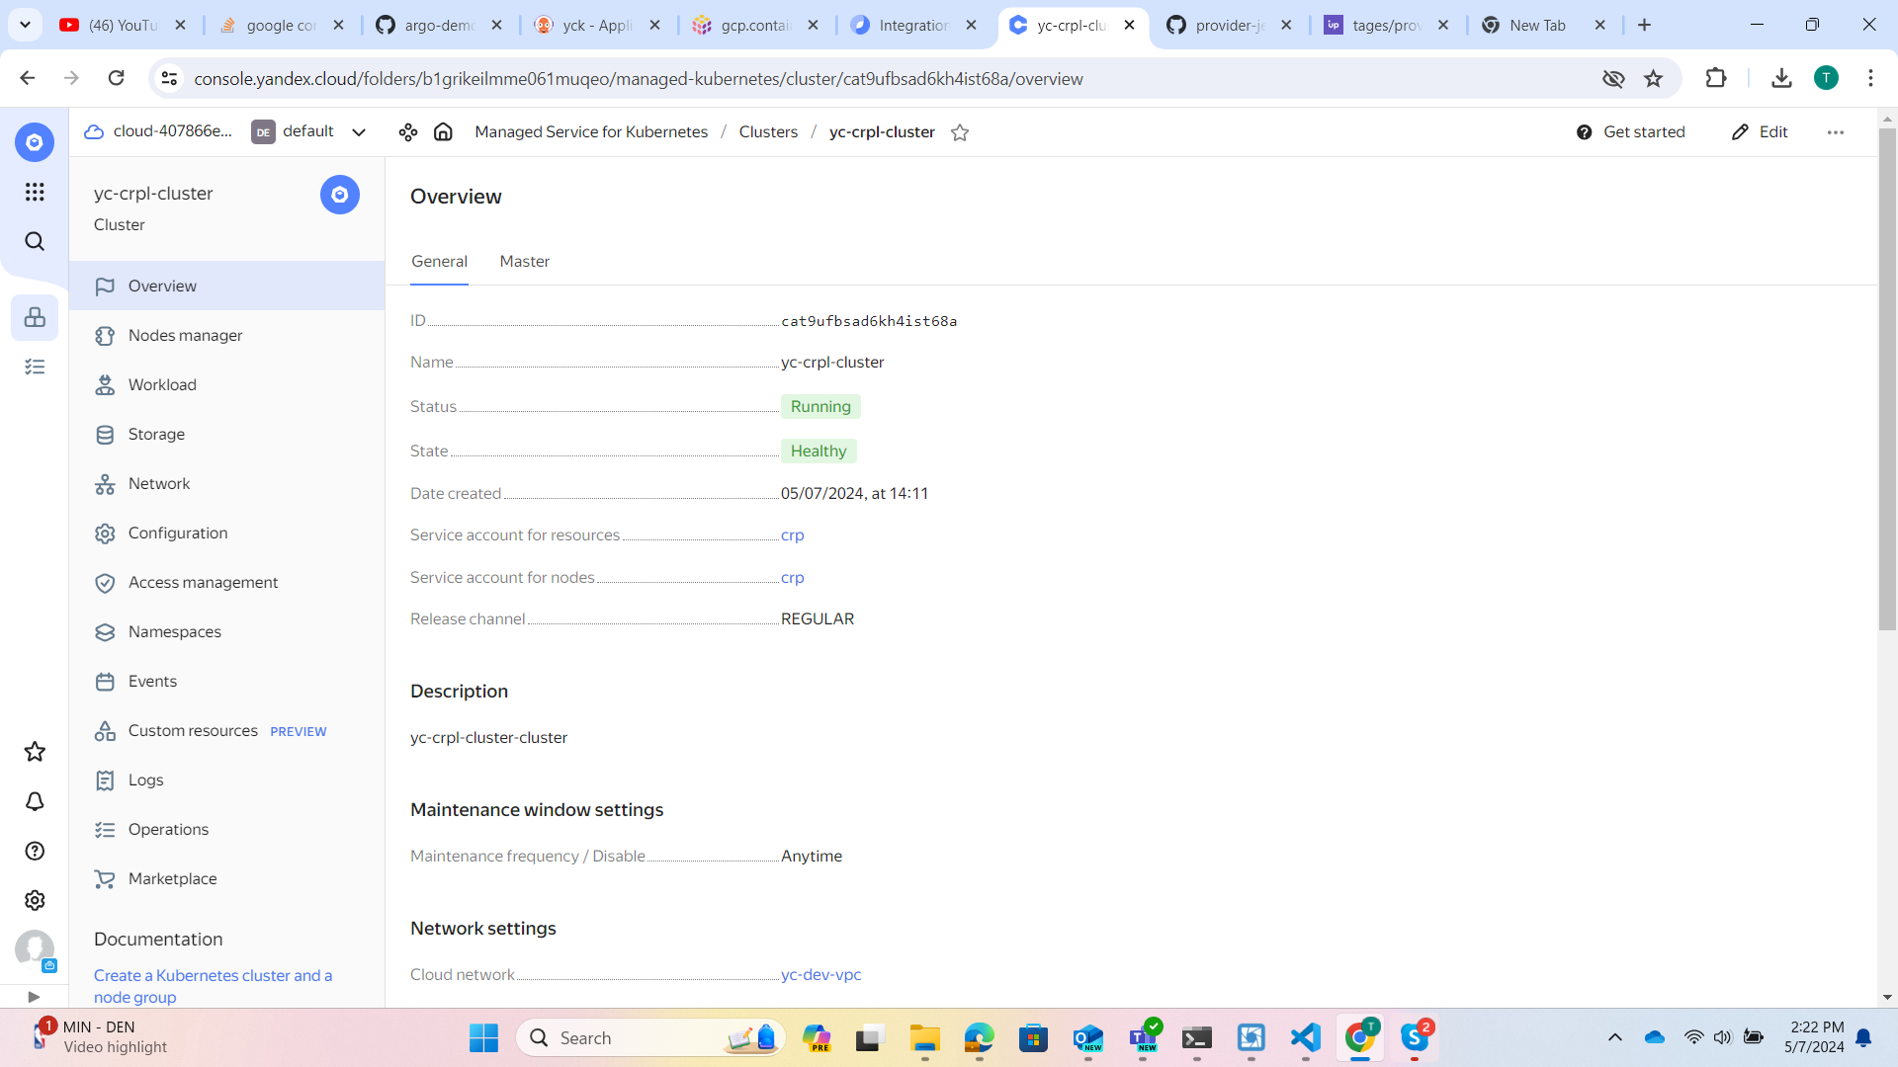

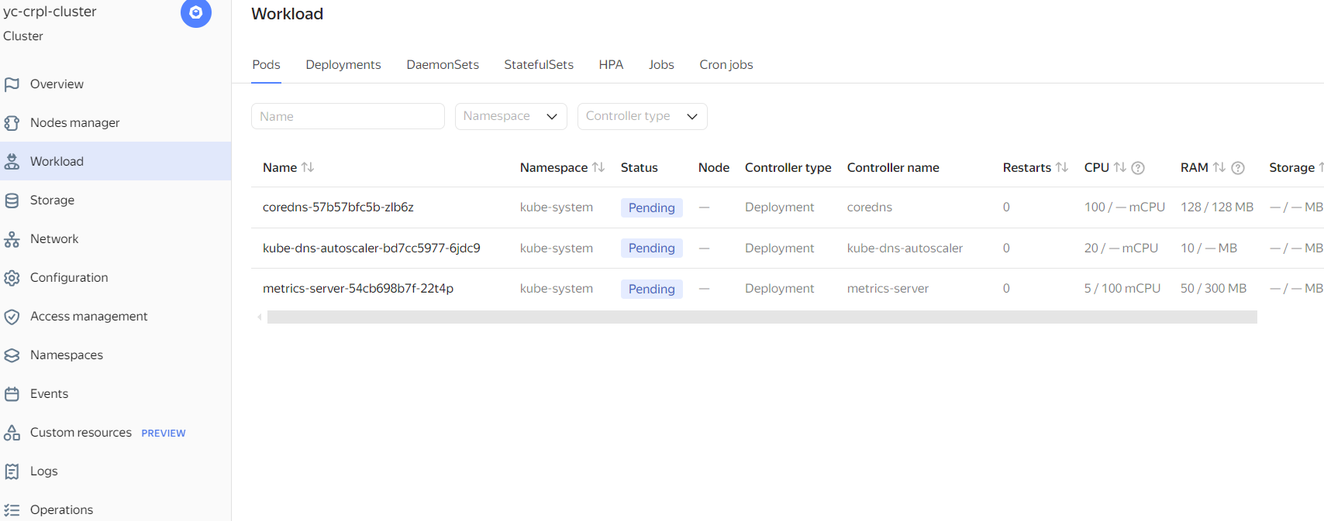

FIN.